  
FEST Research Group

Final Year Project Proposal   
(Feasibility Functional/Nonfunctional Requirements, Use Case, ERD)

|  |  |
| --- | --- |
| **Project Title:** | KIDSTUBE |
| **Degree Program/ Title:** | Computer Science |

|  |  |  |  |
| --- | --- | --- | --- |
| Project Supervisor: |  | Signature: |  |
| Project co-supervisor: |  | Signature: |  |

|  |  |  |
| --- | --- | --- |
| Student Name & Registration No: | Email & Phone Number: | Student Signature: |
| Misbah Aslam Sheikh 28272 | [misbah.asl96@gmail.com](mailto:misbah.asl96@gmail.com) 03009210111 |  |
| Muneeb Ahmed 28863 | [muneebahmed39@yahoo.com](mailto:muneebahmed39@yahoo.com) 03022220672 |  |
| Anosha Ilyas 32356 | [saadilyas49@gmail.com](mailto:saadilyas49@gmail.com) 03312087744 |  |

1. **Introduction/Abstract**:  
   In today’s world everyone is using smartphones and apps even small children’s uses apps like YouTube to watch funny videos and cartoons. YouTube has created a special app for kids known as YouTube Kids where there is content for small kids like cartoons and videos, and all the necessary functions that parents need in today’s worldly technology in order control the child’s activity and routine using YouTube. Our project will be the replica of the existing app but some of functions might get changed basis on Pakistani culture only.

Our prime objective is to create a platform where children can enjoy videos which are relevant and good for them and which will also help in their right growth since there is religious and ethical content as well in assistance with parents.

1. **Purpose:**  
   The purpose of this project is to provide a particular platform in which a child of below 7 age can easily spend their time watching certain things on the app without parents’ guide. This document will specify the feasibility study to the requirements analysis of the project with particular flow model in order to make things understandable.
2. **Scope:**  
   The scope of this project defines the fulfillments of parents need and to satisfy them with such a thing on which they can blindly trust and let their children depend upon it for such activities than YouTube without having any advertisement, or any other act that parents won’t like for their child.

*Our goal is to provide or made the replica of the product with certain amendments that’s requires   
*Time limit of watching any video  
*No comments  
*No user is allowed to sign up or upload the video(decision can be changed)  
*Only the owner has the right to upload and delete the content by the reviews of the people on app store  
*All types of youngest interest will be tried to update in the application based on our culture  
*Cartooned characters, educational videos we will enforce Islamic videos too that includes the recitation of Qaida to Quran Paak including duas and naat  
*Time limit will be applied manually by the user(parent)  
*No promotion of irrelevant advertisement's on the app

1. **Overall Description:**  
   This section will give an overview of the whole system. The system will be explained in its context to show how the system interacts with other systems and introduce the basic functionality of it. It will also describe the type of stakeholders that will use the system and the functionality is available for each one of them.

4.1 **Problems Description:**

The system we decided to made come out because of the following drawbacks:

**\***[YouTube](https://www.youtube.com/)**is public, so, anyone can see the videos that you post, anyone can post a video, there could be copyright infringement issues, and there could be issues of privacy invasion.**

**\*If the children can access**[YouTube](https://www.youtube.com/)**, you probably need a parental block, some videos can sometimes be inappropriate without warning, there is violence on some of the videos, there are explicit videos and the teens are recording violence to post on**

*For particular children need YouTube has created special app for the youngest fans that offers particular dilemma according to respective needs but this also has certain things that is not preferred by our country policy.

4.2 **Project Objective:**

Develop an app considering the needs of a child and preferment of the parent according to our culture and environment needs without having any advertisement of adds in the app.

1. **Feasibility Study:**

A feasibility study is conducted to select the best system that meets the performance requirements. This entails an identification description, an evaluation of candidate systems, and the selection of the best system for the job. Three key considerations are involved in feasibility analysis: economic, technical and behavioral.

We have conducted feasibility study for our project so that we can know whether the project on which we want to work on is feasible technically, operationally, economically, legally or not.

* 1. **Statement Of Constraints:**

Constraints are factors that limit the solution of a problem. Some constraints which are identified in this project during the initial investigation are as follow:

*No irrelevant promotions on the applications

*No one is allowed to upload a video except the owner

*Videos which are good for children's of age 7 or less will be uploaded

5.2 **Identification Of System Objectives:**

Once the constraints are spelled out. The analyst proceeds to identify the system’s specific performance objectives. They are derived from the general objectives specified in the project directive at the end of the initial investigation. The steps are to state the system’s benefits and then translate them into measurable objectives.

Our objective is to build such an application which will help the children to watch the cartoons & videos which are good for their minds and parents remain worry free.

5.3 **Description Of Outputs:**

A final step in system performance definition in describing the output required by the user. An actual sketch of the formal and contents of the reports as well as a specification of the media used their frequency, size and numbers of copies required are prepared at this point.

5.4 **Feasibility Considerations:**

5.4.1 **Legal Feasibility:**

Determines whether the proposed system conflicts with the legal requirements, approval of the senior’s assistants and clients of the project and university policies in order to meet the legal requirements of the project that wouldn’t harm any association or leading requirement/character in the project.

We will use all the tools required for the development of the app & other relevant for this project which are freely available or we will buy it to avoid any legality in near future. We will upload videos in this app such that their arises no copyright infringement issues.

5.4.2 **Operational Feasibility:**

We have a team that has knowledge of application & software development so there may not arise any problem regarding this in near future. This application will be designed solely for children's so there will be the videos and content that is of children's interest or benefit so this app will proved to be very beneficial for parents who remain concerned about what their child is watching on internet, so it will be a very useful system. This will be promoted well by the team so that it becomes acceptable by the people and they use this application for their children's benefit & fun under their control & it will be very easy and secure to use even for a person who does not have much technological knowledge.

There exists an app like this made by YouTube named as YouTube kids but there are certain flaws in the apps which will be resolved by us in our application.

Process: Throughout the development of the app we will take suggestions from different people about improvements which may help to redesign it in a better way and we analyze those suggestions if they are proved to be beneficial we will work on it.

Evaluation**:** This application will be beneficial for all stakeholders. This app may be a threat for the existing YouTube kids’ app (If become popular) because it overcomes the flaws in YouTube kids app. The threat for this app is that we may counter problems while uploading videos on the app due to copyright infringement

Implementation:We have almost all the resources needed to go forward with this project that is human resources, financial resources & technical resources.

Resistance: Many people are resistant to use any new app because they think that app might use their data wrongly or this app may incur negative impact on the device & minds of users. To counter this we will promote in such a way that it is used by peoples efficiently and without any doubt.

## 5.4.3 Economical Feasibility: The purpose of the economic feasibility assessment is to determine the positive economic benefits to the organization that the proposed system will provide. It includes quantification and identification of all the benefits expected. This assessment typically involves a cost/benefits analysis.

We have done a cost estimation for our project to get to know that are project is feasible economically which is as follow

**Cost Estimation**

|  |  |  |  |  |
| --- | --- | --- | --- | --- |
| **Serial No** | **Resources** | **Unit Cost** | **Quantity** | **Total Cost for 4 months** |
| 01 | Senior Front hand  developer(GUI) | 20000 | 01 | 80000 |
| 02 | Junior Front hand  developer(GUI) | 25000 | 01 | 60000 |
| 03 | Backhand developer | 30000 | 01 | 120000 |
| 04 | JuniorBackhand developer | 27000 | 01 | 108000 |
| 05 | Designer | 23000 | 01 | 46000 |
| 06 | Database Developer | 28000 | 02 | 112000 |
| 07 | Software Quality Tester | 20000 | 02 | 160000 |
| 08 | Project Manager | 30000 | 01 | 120000 |
| 09 | Software Promotion | 50000 (depends upon the market rate) | 01 | 50000 |
| 10 | Hardware (laptop+soft) | 120,000 | 01 | 120,000 |

We will hire whole team for this project so there salary will be included in cost of the budget. The above table display the cost that is required to complete this project i.e. Rs. 976000.

5.4.4 **Technical Feasibility:**

Compatibility: The technology (i.e. the framework) which has to be use is compatible/supportable to run on any device with latest updates or user end.  
Upgradeability: The system is to be developed and design in such a manner that it will be viable to upgrade the system in future with ease.  
Technical capacity/skills: The skills required to develop this system exist locally within our team however if the project require more assistance as per clients need it can be managed.  
Hardware: We do have the required hardware requirements to run the software which are needed for app development and database. Moreover from the user side, there are no advance hardware requirements because this is an android application so it’s only required an active internet connection and an android phone.  
Upgradeable Project: The software used and database requirements are viable for this project and can be altered in future if required. The framework technology and the layout design which is used in this project is feasible to manage in future and are considered technically upgradeable and our team is capable to future assistance. Methodologies, techniques and skills required for support assistance are feasible and the project can be done technically.

1. **Functional Requirements:**  
   1. Sign up/Login:  
    Parent is allowed to sign up the app by entering their date of birth and email to verify the registrations.  
   2. Search Option:  
    Search option will be created in order to find the user’s desired thing.  
   3. Create Playlist:  
    Parents have the option to create playlist of their own and lock the screen so child won’t be able to search any content or video without parent’s permission.  
   4. Timeout:  
    Feature of Timeout will also be provided in order to make child not fully dependent upon the phone/ YouTube. After a certain interval of time the app will automatically close for estimated time.  
   5. Resuming:  
    When the interval of time limit finishes the app will be resumed to playlist of default page or to the parents playlist until and unless it is unlocked.  
   6. Feedback:  
    Parents will give feedback that whether the particular video is good to be watched or something new should be added or to be removed.
2. **Nonfunctional Requirements & Extra Additional Requirements**  
   1. Availability:   
    This application will be available on play store and app store for users to install and use it. It should be available to use 24/7 for users (except for the time of maintenance of app).2. Modifiable:   
    This application will be modifiable according to the changing needs and requirements of potential user  
   3. Scalability:   
    This application shall be expandable to accommodate the increase in no of users.  
   4. Secure:  
    The app will be secure enough as no user is supposed any sort of this until the feature is introduced in the app.  
   5. Advertisement/Uploading:  
    No user is allowed to upload the video and no comments will be allowed to post, with that any sort of advertisement during the playlist or opening the app won’t be promoted either it is paid or unpaid.  
   6. Performance Optimization:  
    A record of performance would be maintained that how much user is paying interest to the product by using it and refreshing the page or playing the videos.  
   7. Child Birthday Theme:  
    A birthday themed page setup will be displayed on child’s birthday provided by the user/parent.
3. **Model Analysis**

8.1 **Block Diagram**

According to user’s aspect

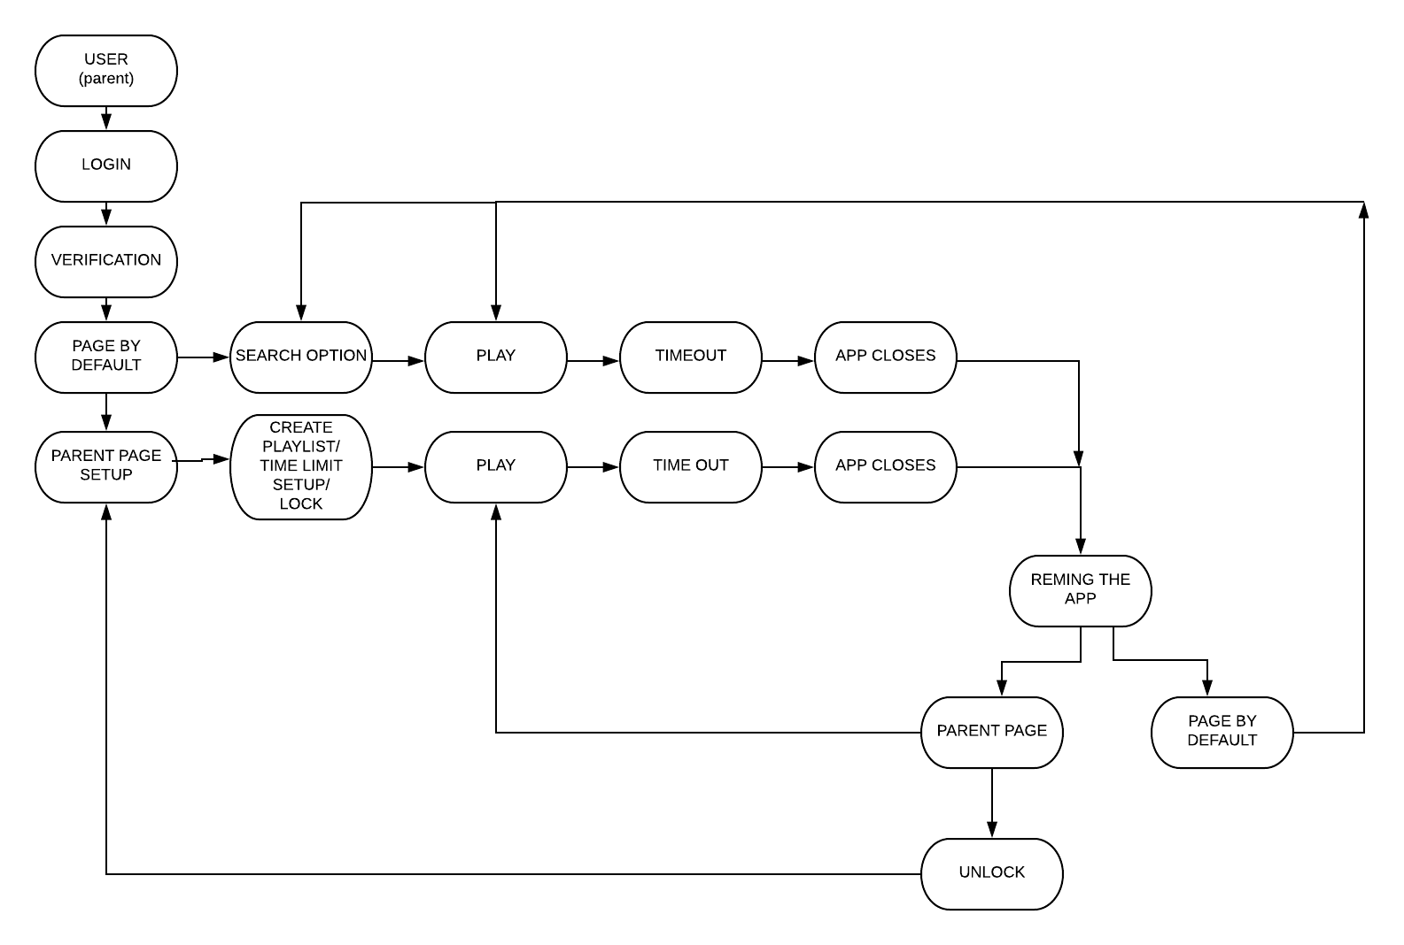

Actual product/model/application may be differ from the initialization

8.2Use Case Diagram

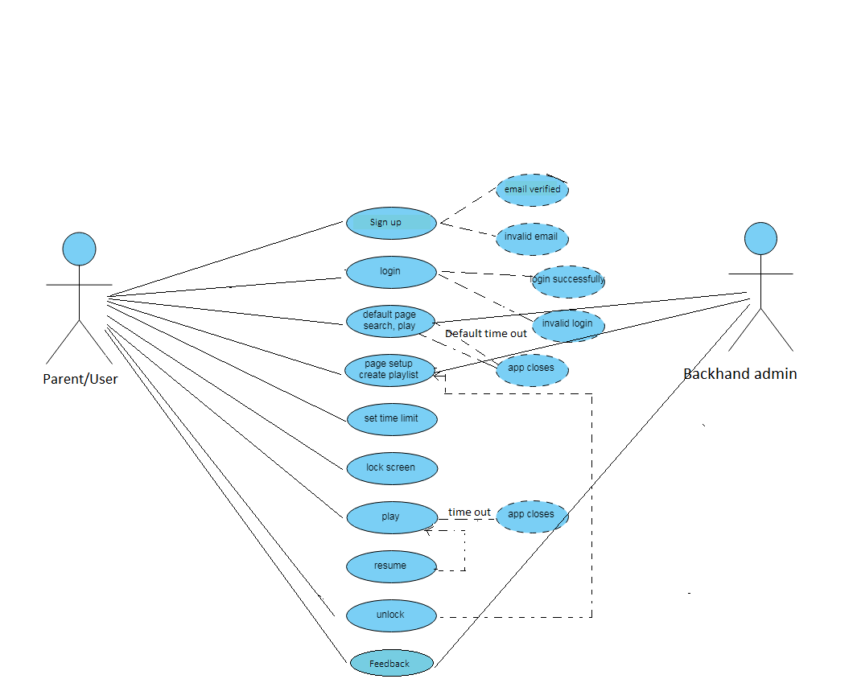

User’s aspect

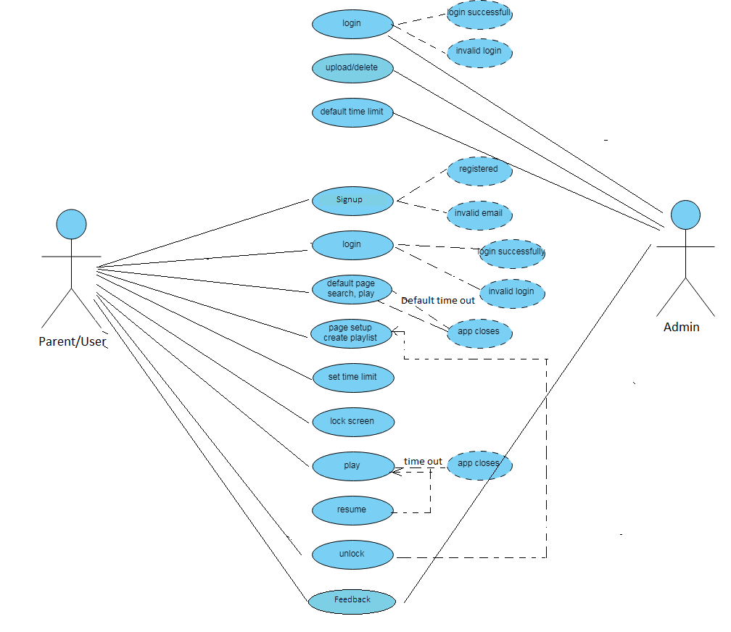

Admin’s & User’s both aspect

8.2.1 Use Case Narratives

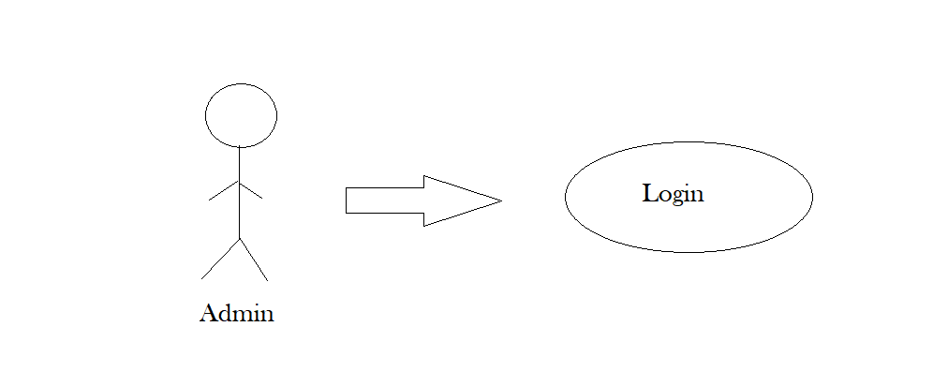

|  |  |
| --- | --- |
| **Use Case Name** | Login, extends Invalid Login & Valid Login |
| **Use Case ID** | UC – 01 |
| **Actor** | Admin |
| **Description** | This use case describes the event of admin logging in to the app. |
| **Flow of Events** | 1. This use case begins when admin wants to login. 2. Prove identity through ID and Password. 3. If authentication is valid, it will go to the valid login and display the admin screen. 4. If authentication is invalid, it will go to the invalid login and display error message. |

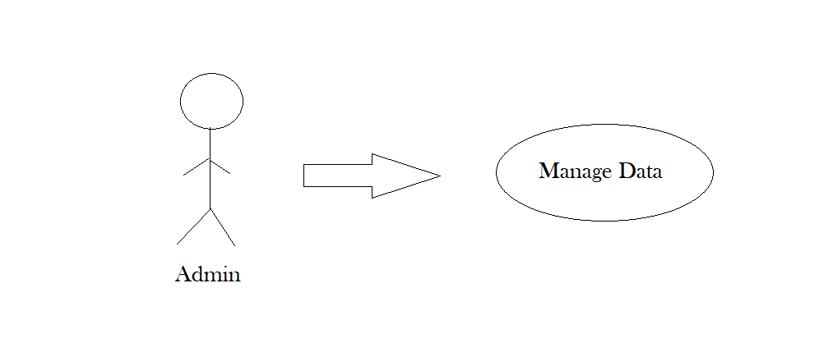

|  |  |
| --- | --- |
| **Use Case Name** | Upload & Delete Videos |
| **Use Case ID** | UC – 02 |
| **Actor** | Admin |
| **Description** | This use case describes the event of admin uploading a new video on app and deleting a video from the app. |
| **Flow of Events** | 1. This use case begins when admin logins. 2. Admin selects the upload or delete video option. 3. If upload video option is selected, screen will be displayed where admin is prompt to upload a video with the descriptions (Optional). 4. Video will be uploaded on the application. 5. If delete video option is selected, screen will be displayed where there is list of videos and admin selects the video he wants to delete and confirm delete. 6. Video will be deleted from the application. |

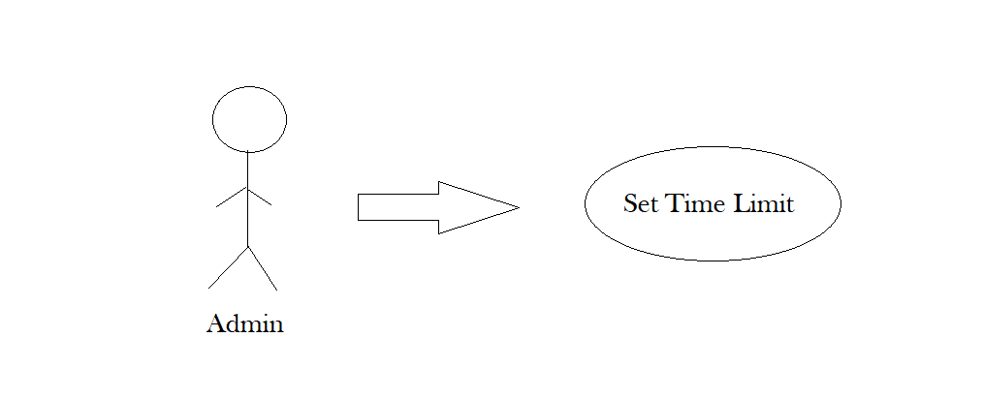

|  |  |
| --- | --- |
| **Use Case Name** | Set Default Time Limit (One Time) |
| **Use Case ID** | UC – 03 |
| **Actor** | Admin |
| **Description** | This use case describes the event of admin setting default time limit. |
| **Flow of Events** | 1. This use case begins when admin logins. 2. Admin selects the set default time limit option. 3. Screen is displayed where admin is prompt to set time limit (one time) for watching certain videos. 4. Default time limit will be saved. |

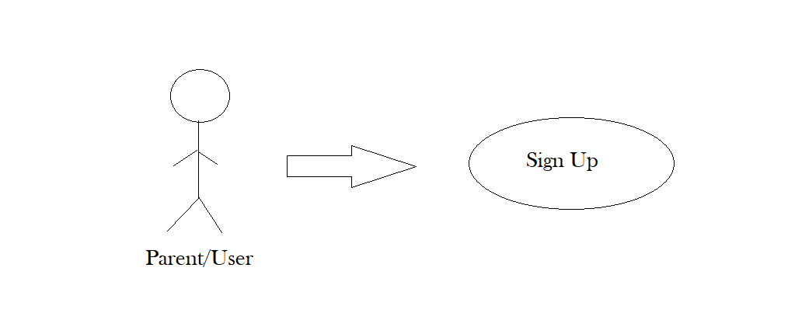

|  |  |
| --- | --- |
| **Use Case Name** | Signup |
| **Use Case ID** | UC – 04 |
| **Actor** | Parent/User |
| **Description** | This use case describes the event of new user to sign up on the app. |
| **Flow of Events** | 1. This use case begins when new user wants to use the app. 2. User selects sign up option. 3. Fill up the sign up form and submit. 4. After certain verifications user will be registered. |

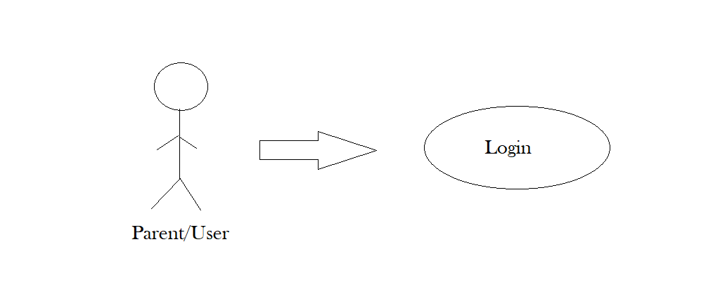

|  |  |
| --- | --- |
| **Use Case Name** | Login |
| **Use Case ID** | UC – 06 |
| **Actor** | Parent/User |
| **Description** | This use case describes the event of user logging into the app. |
| **Flow of Events** | 1. This use case begins when user wants to login 2. User prove identity through ID & Password 3. If authentication is valid, it will go to the valid login and display the admin screen. 4. If authentication is invalid, it will go to the invalid login and display error message. |

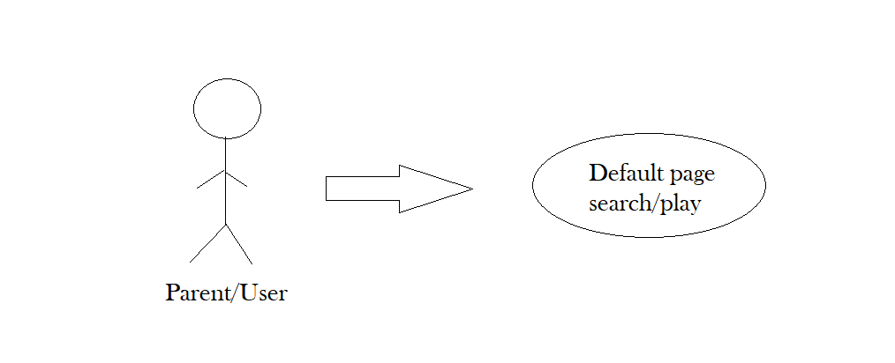

|  |  |
| --- | --- |
| **Use Case Name** | Default Page Search & Play extends App Closes |
| **Use Case ID** | UC – 07 |
| **Actor** | Parent/User |
| **Description** | This use case describes the event of screen set to default search & play |
| **Flow of Events** | 1. This use case begins when user logins. 2. User selects default search and default play. 3. Then the videos in the default will be played. 4. After the videos finish, app will close. |

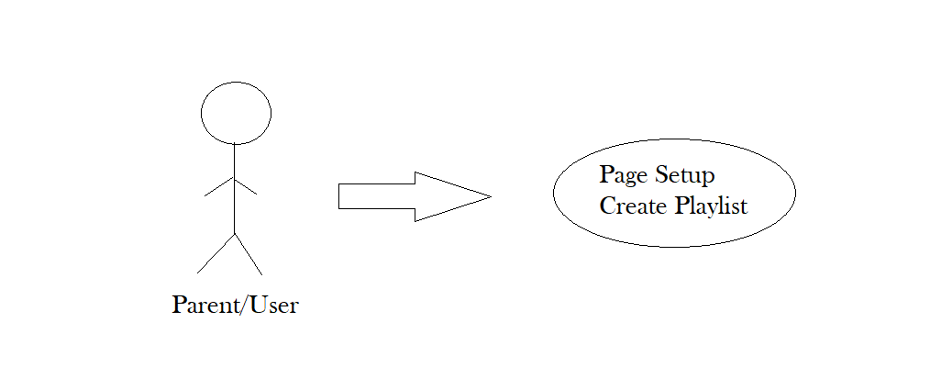

|  |  |
| --- | --- |
| **Use Case Name** | Page Setup & Create Playlist |
| **Use Case ID** | UC – 08 |
| **Actor** | Parent/User |
| **Description** | This use case describes the event of user creates his own playlist and set page according to him. |
| **Flow of Events** | 1. This use case begins when user logins. 2. Selects Page setup or create playlist option. 3. Selects videos of which he wants to create playlist. 4. Playlist will be created. |

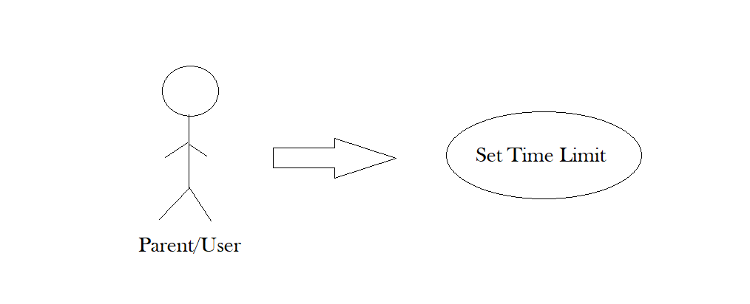

|  |  |
| --- | --- |
| **Use Case Name** | Set Time Limit |
| **Use Case ID** | UC – 09 |
| **Actor** | Parent/User |
| **Description** | This use case describes the event of user setting the time limit for their child to use the app. |
| **Flow of Events** | 1. This use case begins when user logins. 2. User selects the set time limit option. 3. Specify the duration 4. Time limit is set. |

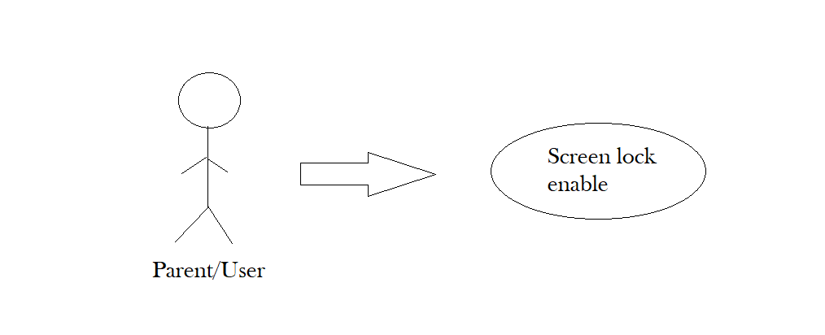

|  |  |
| --- | --- |
| **Use Case Name** | Lock screen |
| **Use Case ID** | UC – 10 |
| **Actor** | Parent/User |
| **Description** | This use case describes the event of screen locking after the end of set time. |
| **Flow of Events** | 1. This use case begins when user is using the app. 2. User selects the option lock screen or after timeout screen will be locked automatically. 3. Screen will be disabled. |

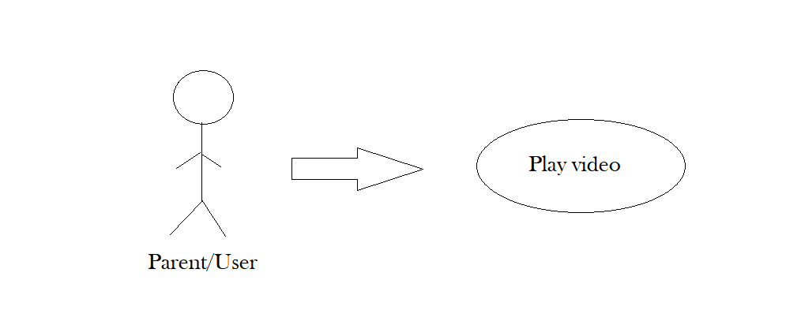

|  |  |
| --- | --- |
| **Use Case Name** | Play Video |
| **Use Case ID** | UC – 11 |
| **Actor** | Parent/User |
| **Description** | This use case describes the event of playing a video. |
| **Flow of Events** | 1. This use case begins when user logins. 2. User select the playlist or video. 3. Video will be played. |

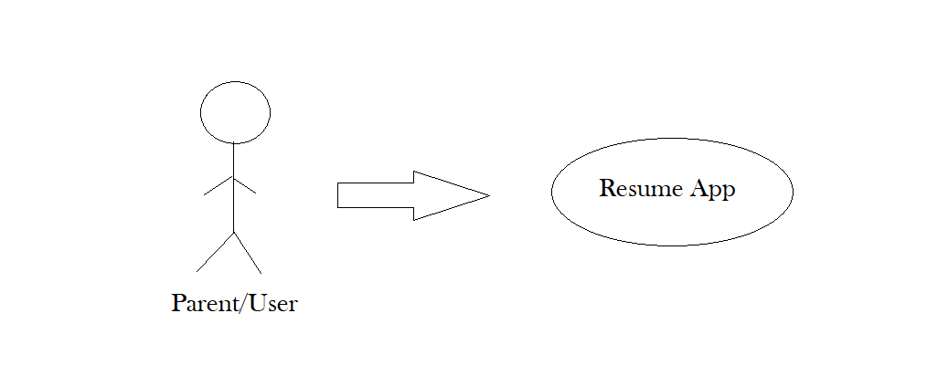

|  |  |
| --- | --- |
| **Use Case Name** | Resume video |
| **Use Case ID** | UC – 12 |
| **Actor** | Parent/User |
| **Description** | This use case describes the event of user resuming the video. |
| **Flow of Events** | 1. This use case begins when the app is closed or screen is locked. 2. User unlocks the screen (If locked). 3. Video or playlist will be resumed from where user paused or stopped it. |

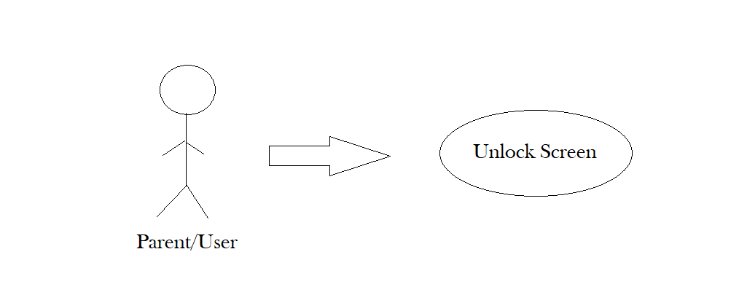

|  |  |
| --- | --- |
| **Use Case Name** | Unlock Screen |
| **Use Case ID** | UC – 13 |
| **Actor** | Parent/User |
| **Description** | This use case describes the event of user unlocking the screen. |
| **Flow of Events** | 1. This use case begins when the app is locked & screen is disabled. 2. User enables or unlock the screen by selecting unlock or enable option. 3. Screen is unlocked. |

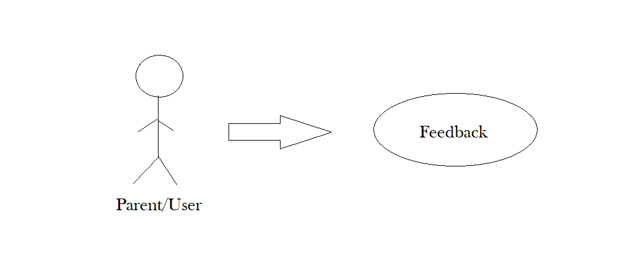

|  |  |
| --- | --- |
| **Use Case Name** | Feedback |
| **Use Case ID** | UC – 13 |
| **Actor** | Parent/User |
| **Description** | This use case describes the event of user feedback to the admin related to video, application or the updating data. |
| **Flow of Events** | 1.This use case provides the option of feedback at the front of the screen.  2.User can review the application or the video through feedback option.  3.User can ask for the video updating/uploading through feedback option. |

8.3 Entity Relationship Diagram

